
SRM Institute of Science and Technology
Mode of Exam
OFFLINE
College of Engineering and Technology
School of Computing
DEPARTMENT OF COMPUTING TECHNOLOGIES
SRM Nagar, Kattankulathur – 603203, Chengalpattu District, Tamilnadu
Academic Year: 2023-2024 (ODD)
Test: CLAT-1 Date: 09-08-2023
Course Code & Title: 18CSE458T – Wireless and Mobile Communication Duration: 50 Minutes
Year & Sem: IV Year – VII Semester Max. Marks: 25

Course Articulation Matrix: (to be placed)

Part - A
( 5 x 1 = 5 Marks)
Instructions: Answer all
Q. No | Question | Marks | BL | CO | PO | PI Code
1 | The maximum outdoor range in WIFI wireless communication technology is ______?  - 100m  - 10-1000m  - 10m  - None of the above | 1 | 1 | 1 | 1 | 1.6.1
2 | Which of the following is not a linear modulation technique?  a) π/4 QPSK  b) OQPSK  c) BPSK  d) FSK | 1 | 2 | 1 | 1 | 1.6.1
3 | What is the set of possible carrier frequencies in FH-SS?  a) Hop  b) Hopset  c) Symbols  d) Chips | 1 | 1 | 1 | 1 | 1.6.1
4 | Which of the following are devices that turn information or data into electromagnetic waves that may be delivered wirelessly?  a)Transmitters  b)Contributors  c)Diffuser  d)None of the above | 1 | 2 | 1 | 1 | 1.6.1
5 | The width of each channel in frequency hopping spread spectrum corresponds to  a) Bandwidth of input signal  b) Pseudorandom sequence used  c) Carrier frequency  d) None of the mentioned | 1 | 1 | 1 | 1 | 1.6.1
Part – B
( 5 x 2 = 10 Marks)
Instructions: Answer all
6 | List out the advantages of Wireless communication | 2 | 1 | 1 | 1 | 1.6.1
7 | Define Electromagnetic Wave | 2 | 1 | 1 | 1 | 1.6.1
8 | Classify Simplex, Half-Duplex and Full-Duplex | 2 | 2 | 1 | 1 | 1.6.1
9 | Classify Modulation and Demodulation in detail | 2 | 2 | 1 | 1 | 1.6.1
10 | Give example for Frequency Division Multiplexing | 2 | 2 | 1 | 1 | 1.6.1
Part – B
( 1 x 10 = 10 Marks)
Instructions: Answer any one
11 a  11 b | Illustrate Amplitude Shift Keying, Frequency Shift Keying and Phase Shift Keying in detail with neat sketch  (or)  Explain Frequency Hopping Spread Spectrum and Direct Sequence Spread Spectrum with neat Diagram | 10 | 2 | 1 | 1 | 1.6.1

*Performance Indicators are available separately for Computer Science and Engineering in AICTE examination reforms policy.

Course Outcome (CO) and Bloom’s level (BL) Coverage in Questions

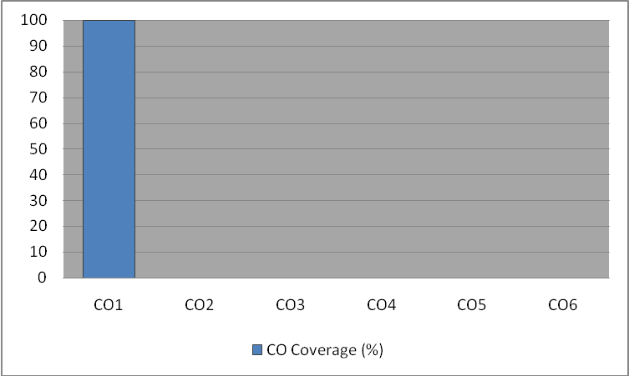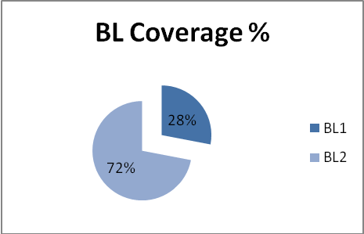

Approved by the Audit Professor/Course Coordinator

